CMSC 204
Huffman Lab
- Create a Huffman Tree and generate the codes for each character of the following input:
create a huffman tree
For consistency:
- If same frequency – put in priority queue alphabetically; put space before other characters of the same frequency
- Add subtrees to end of group with same priority
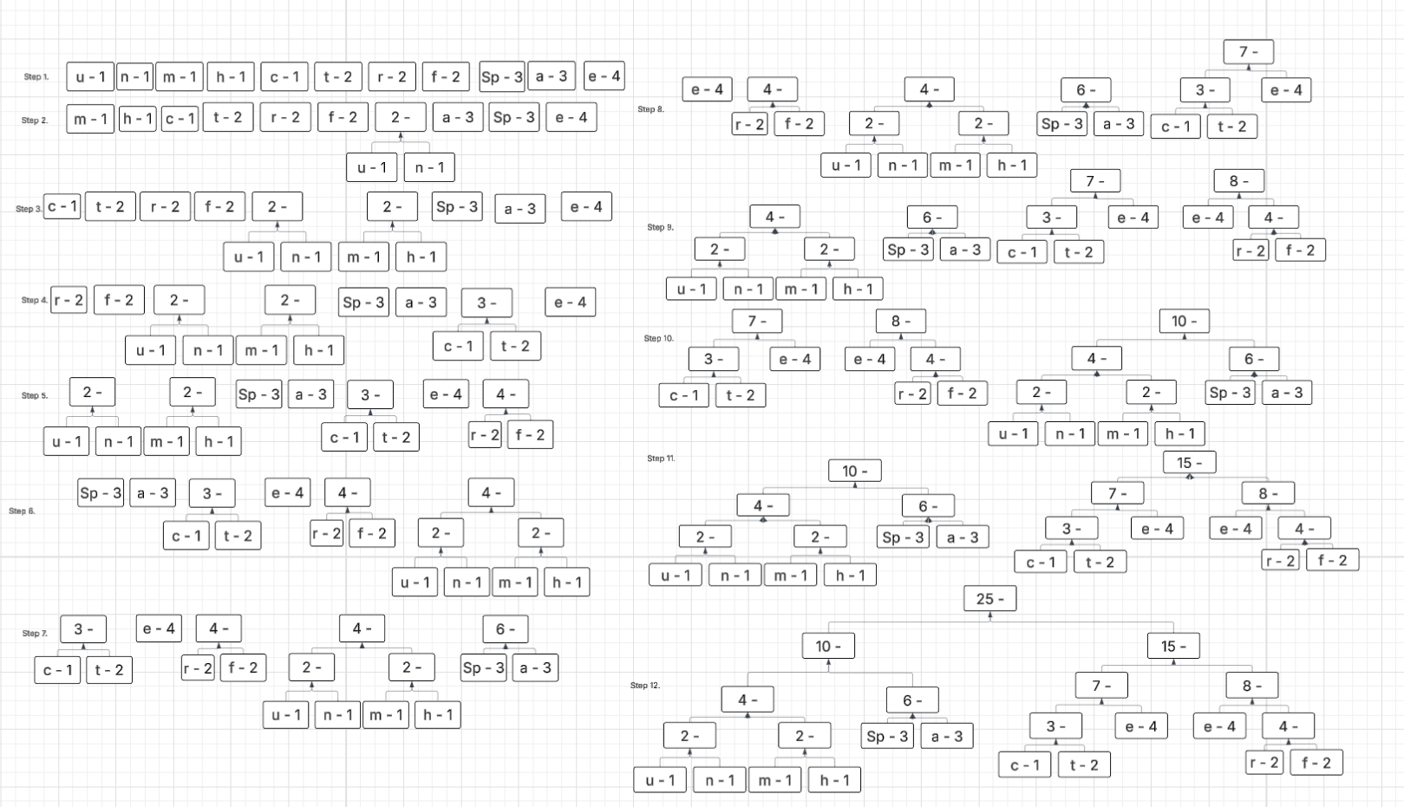
- Lower number has higher priority (goes to front)

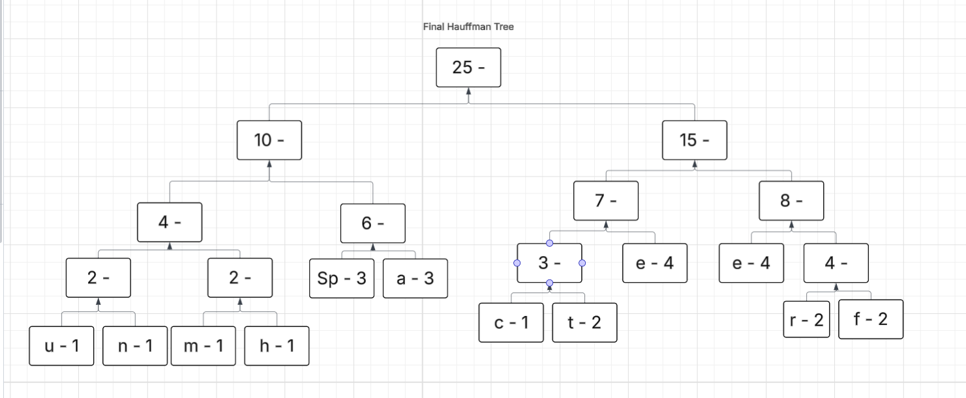

Table:
Letter freq code
e | 4 | 101
Space | 3 | 010
a | 3 | 011
f | 2 | 1111
r | 2 | 1110
t | 2 | 1001
c | 1 | 1000
h | 1 | 0011
m | 1 | 0010
n | 1 | 0001
u | 1 | 0000

Now encode “create a huffman tree” :
// One string
10001110101011100110101001101000110000111111110010011000101010011110101101
// Split text
1000 1110 101 011 1001 101 010 011 010 0011 0000 1111 1111 0010 011 0001 010 1001 1110 101 101

- Based on the following Huffman tree and binary sequence, what is the text

0 – left
1 – right

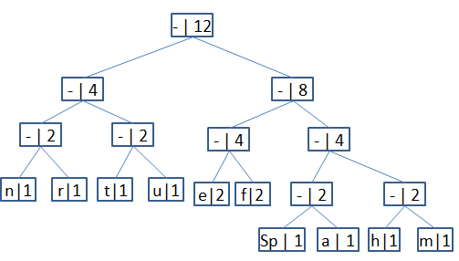

1110 011 101 101 1111 1101 000 1100 010 001 100 100
H u f f m a n (space) t r e e

